* **Activity 8:**

### Restricting Group Results Using the HAVING Clause

1. **The countries where the total ticket price is greater than 1000:**

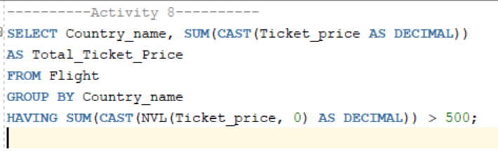

Output:

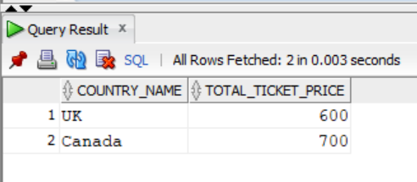

1. **Restricting by Maximum Flight Duration**

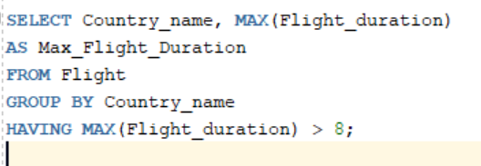

Output:

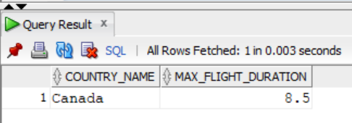

1. **Using WHERE and HAVING Together**

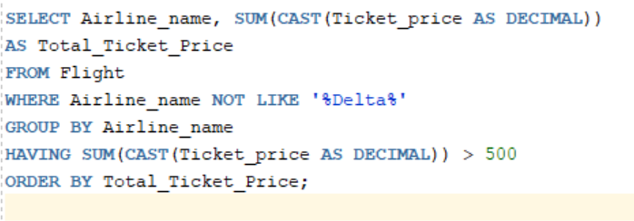

Output:

